
Bonytail (Gila elegans): Proposed Integrated Population Model
LCR MSCP Native Fish Data Synthesis, Phase 3 · Sub-Task 2: Bonytail Demographic Analysis
Sound Science LLC · 10 July 2026
DRAFT FOR ADVISORY PANEL REVIEW

1. Purpose and scope
This document describes the integrated population model (IPM) proposed for bonytail (BONY) under Sub-Task 2 of Phase 3. It is intended to orient reviewers to the model's biological basis, its structure as a Bayesian graphical model, the data streams it consumes, and the parameters it estimates.
Bonytail is among the most endangered fishes in North America and is now maintained in the Lower Colorado River almost entirely through hatchery production: fish are reared to adult size and stocked, rather than recruiting naturally at scale. This fact shapes the entire modeling approach. The BONY analysis therefore comprises two complementary components that reflect the contrasting demographic patterns observed in off-channel habitat (OCH) ponds versus open-water releases:
- Off-channel (OCH) stage-structured IPM: a full state-space population model fitted to data collected following BONY releases into predator-free conservation ponds (Cibola High Levee Pond [CHLP] and Imperial Ponds Conservation Area [IPCA], plus Yuma Cove and ephemeral backwaters where data support), which show demographic continuity across years and, in isolated ponds, documented natural reproduction.
- Open-water Cormack–Jolly–Seber (CJS) model: a survival-only model fitted to post-release encounter data across all mainstem reaches. A full IPM is not warranted in open water because apparent post-release six-month survival is near zero. Stocked fish largely disappear within weeks, assumed due chiefly to predation by birds and fishes, with an estimated 85% perishing within the first month (Kelley et al. 2022); they do not persist across years, and there is no demographic continuity for a process model to track. Consistent with this, open-water survival is modeled on a weekly time-since-release scale (a post-release recovery curve rather than an annual rate), because mortality is concentrated in the first weeks after release; detection is effort-aware and method-specific (net versus PIT-antenna).
The two components together quantify the OCH-versus-open-water survival contrast that underpins the MSCP question of the relative merits of releases into disconnected-versus-connected backwaters, and they supply the vital-rate estimates and covariate effects used later for alternate-stocking scenario analysis and refuge-site feasibility ranking. Sub-Task 2 addresses research questions Q2, Q3, Q6, and Q7 for BONY, and Q15 (refugia environmental thresholds at CHLP/IPCA).

2. The bonytail life cycle
The model's biological backbone is the LCR MSCP Bonytail Conceptual Ecological Model (Braun 2019, Figure 1), collapsed to the annual time step used by the IPM. Four stages are carried (Figure 1). Spawning is treated as a within-year process folded into the reproduction term rather than a separate projected stage, so that spawning survival is not double-counted against adult survival.
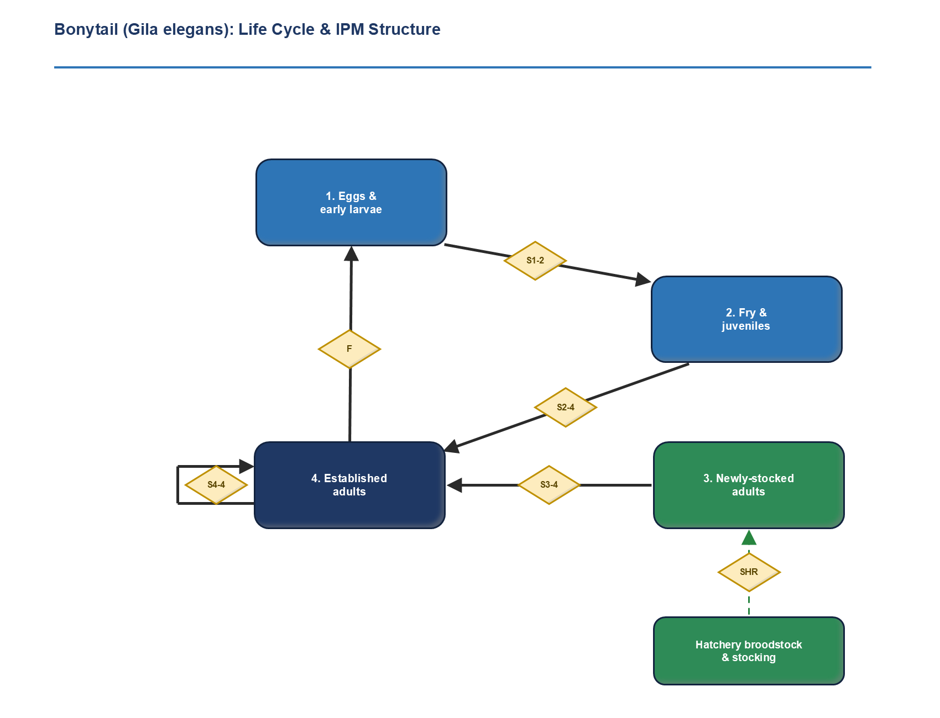
Figure 1. Bonytail life cycle and IPM structure, adapted from the BONY Conceptual Ecological Model (Braun 2019). Diamonds are life-history rates; the annual time step folds spawning into the reproduction term F.
Two features distinguish the bonytail cycle from a conventional wild-fish life history:
- Stocking is the dominant input. Hatchery broodstock produce fish that are stocked as adults (not fry) into the “newly-stocked adult” stage. Stocking enters the IPM as a known quantity (dashed input), not an estimated rate.
- Natural recruitment closes the cycle only in isolated ponds. The early-stage survivals (S1–2, S2–4) and the reproduction term F are realized only in predator-free OCH ponds; in open water the loop effectively does not close.
The CEM's stage-transition labels map onto the IPM's demographic rates as follows; the life-cycle figure retains the CEM “S” notation, while the IPM and its graphical model use φ for survival.
CEM rate (Fig. 1) | IPM parameter | Meaning / where estimable
SHR | (known input) | Hatchery survival / output: stocked adults enter as known additions.
S3–4 | φ³ | First-year post-stocking survival (newly-stocked → established). ~0 in open water (CJS only); estimable in ponds. The first-year advantage is a release effect specific to stocked fish.
S4–4 | φ⁴ | Established-adult annual survival; estimated by the OCH stage-structured IPM (CHLP, IPCA).
S1–2, S2–4 | (early-stage φ) | Wild survival between early stages; realized only in isolated, predator-free ponds.
F | F | Reproduction = spawning participation × per-capita fertility; closes only where recruitment occurs.

3. Model structure as a Bayesian graphical model
Figure 2 renders the single-population BONY IPM as a directed acyclic graph (DAG). It is not a flowchart of the life cycle; it shows how latent demographic quantities generate the observed data, and which parameters are shared across the model's constituent sub-models. The integration, the defining feature of an IPM, appears as the overlaps between the dashed sub-model boxes: a parameter sitting in an overlap is estimated jointly from every data stream that depends on it. This joint-likelihood integration is the defining property of an IPM (Besbeas et al. 2002; Schaub and Abadi 2011), and the graphical-model conventions used here follow Schaub and Kéry (2022).
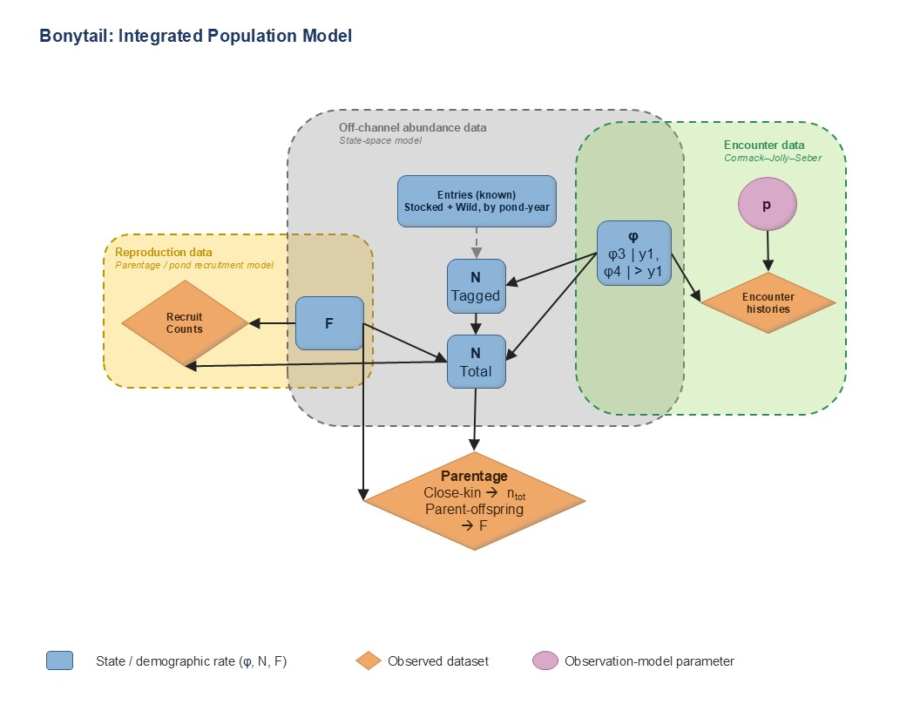
Figure 2. The bonytail IPM as a joint graphical model. Blue = latent states and demographic rates; orange diamonds = observed datasets; pink circles = observation-model parameters. Dashed boxes are the likelihood components; overlaps mark shared parameters.
Three sub-models are joined:
- Reproduction sub-model (gold). The reproduction rate F is informed by parentage / larvae-and-YOY genetic samples, which identify parents and quantify spawning participation and variance in reproductive success (estimation detailed in Section 5).
- Off-channel abundance sub-model (grey; state-space). The stage abundances N³ and N⁴ evolve year to year under survival and the known stocking input, and generate the remote PIT-scanning and net counts in the OCH ponds. The observation error σ governs how true abundance maps to counts.
- Encounter sub-model (green; CJS). Individual PIT-tag encounter histories (OCH ponds and open water) are generated by the survival rates φ³ and φ⁴ together with the detection probability p.
The survivals φ³ and φ⁴ sit in the overlap of the state-space and CJS boxes: they simultaneously drive the abundance trajectory (counts) and the individual encounter histories. That shared dependence is what lets the model reconcile the two data streams into a single, demographically consistent set of estimates rather than two disconnected analyses.
Abundance is recovered by capture-recapture, not by treating the counts as a census. Because every fish carries an individual PIT tag, detection is identified internally: a tagged fish contacted before and after a year but missed within it is known to have been present, and each such gap estimates the detection probability, so the observed counts are scaled to true abundance rather than assumed complete. The pond abundance component is therefore an open-population (Jolly-Seber) state-space capture-recapture model. The two observation methods enter as separate detection probabilities on the same latent N: continuous PIT scanning, with high detection of tagged fish, and episodic netting, with lower detection but the only method that also captures untagged fish. Reconciling both within one N resolves the gap between scan-based and net-based population estimates, and the netted untagged fraction scales the tagged-fish estimate to the total population. This last scaling assumes tagged and untagged fish are equally catchable; where that assumption is not supported, total abundance is anchored instead by within-season closed-population recapture (repeat netting occasions within one season, over which marks are only days old and closure holds), and the robustly estimated quantity is tagged abundance rather than a pond total.
The same genetic data would also support close-kin mark-recapture. Because parentage links individuals through kinship rather than through physical recapture, the genotype panel that estimates F can, in principle, estimate abundance directly: parent-offspring pairs recovered among a genetic sample occur in inverse proportion to adult abundance, so their frequency estimates the total adult population, including untagged and undetected fish, without the tagged-to-total scaling the encounter data cannot support, and half-sibling pairs across cohorts extend the same logic to adult survival (Bravington et al. 2016). The appeal here is independence: close-kin estimates do not use the tagging observation model, so they are unaffected by tag loss, unequal catchability, or gear selectivity, and the reproductive-output structure they require is the participation and variance-in-reproductive-success already estimated for F. Their reach is set by marker power (parent-offspring inference is feasible with the current panel, whereas reliable half-sibling inference would call for a denser SNP panel) and by sampling design, and it is greatest where a population cannot be censused. It is noted here as an extension the genetic data would enable rather than a component of the present model.

4. Data streams and parameters
All datasets are individual-level records linked by PIT-tag ID, reconstructed from release through every subsequent contact (summary tables and aggregated counts are not sufficient). The principal streams and what each informs:
Data stream | Source | Primarily informs
Stocking records | MSCP / Native Fish Database | Known additions to the newly-stocked stage; anchors abundance.
Remote PIT-scan + net encounter histories (OCH) | CHLP, IPCA, Yuma Cove, ephemeral ponds | Abundance N, established-adult survival φ⁴, detection p, recruitment.
Open-water post-release encounters | PIT antennas + physical recapture, all reaches | Post-stocking survival curve φ³ by reach, size at release, release method.
Larvae / YOY genetic (parentage) samples | Osborne et al. (2018) and program data | Reproduction F: spawning participation and variance in reproductive success.
Environmental monitoring | IPCA dissolved oxygen, temperature, water level | Environmental covariates (Q15). The 2020/2022 die-offs were operational (pump failure), not environmental (Marsh et al. 2024).

Estimated quantities are the stage abundances N³ and N⁴; the survivals φ³ (post-stocking) and φ⁴ (established adult); the reproduction rate F, estimated from the annual genetic parentage of pond larvae/YOY (with participation and reproductive-skew estimates as informative priors); the detection probability p; and the observation error σ. Which of these is identifiable depends on the setting: in the predator-free OCH ponds the full set is estimable, whereas in open water only φ³ (and detection) can be recovered, because there is no persistent population for a state-space process to follow.
Detection is not treated as constant. p varies by observation method (remote PIT scanning in open water and the ponds, plus netting in the ponds) and with survey effort and coverage, which differ by site and year; effort enters p as a covariate so that an unevenly sampled year is not misread as a change in survival or abundance. Residual among-individual variation in detectability is accommodated where the data support it, since unmodelled detection heterogeneity biases abundance high and survival low.
Data coverage and which sites the analysis carries
The five off-channel streams shown in Figure 3 below (documented stockings, newly tagged fish, bonytail detected, netting effort, and antenna deployments) are assembled per pond and per year, and it is their coverage, not the raw number of fish, that decides which sites the model can carry. A pond earns a place in the off-channel IPM only where survey effort and recaptures are enough to separate survival from detection; a pond that was stocked but scarcely resurveyed can support neither rate.
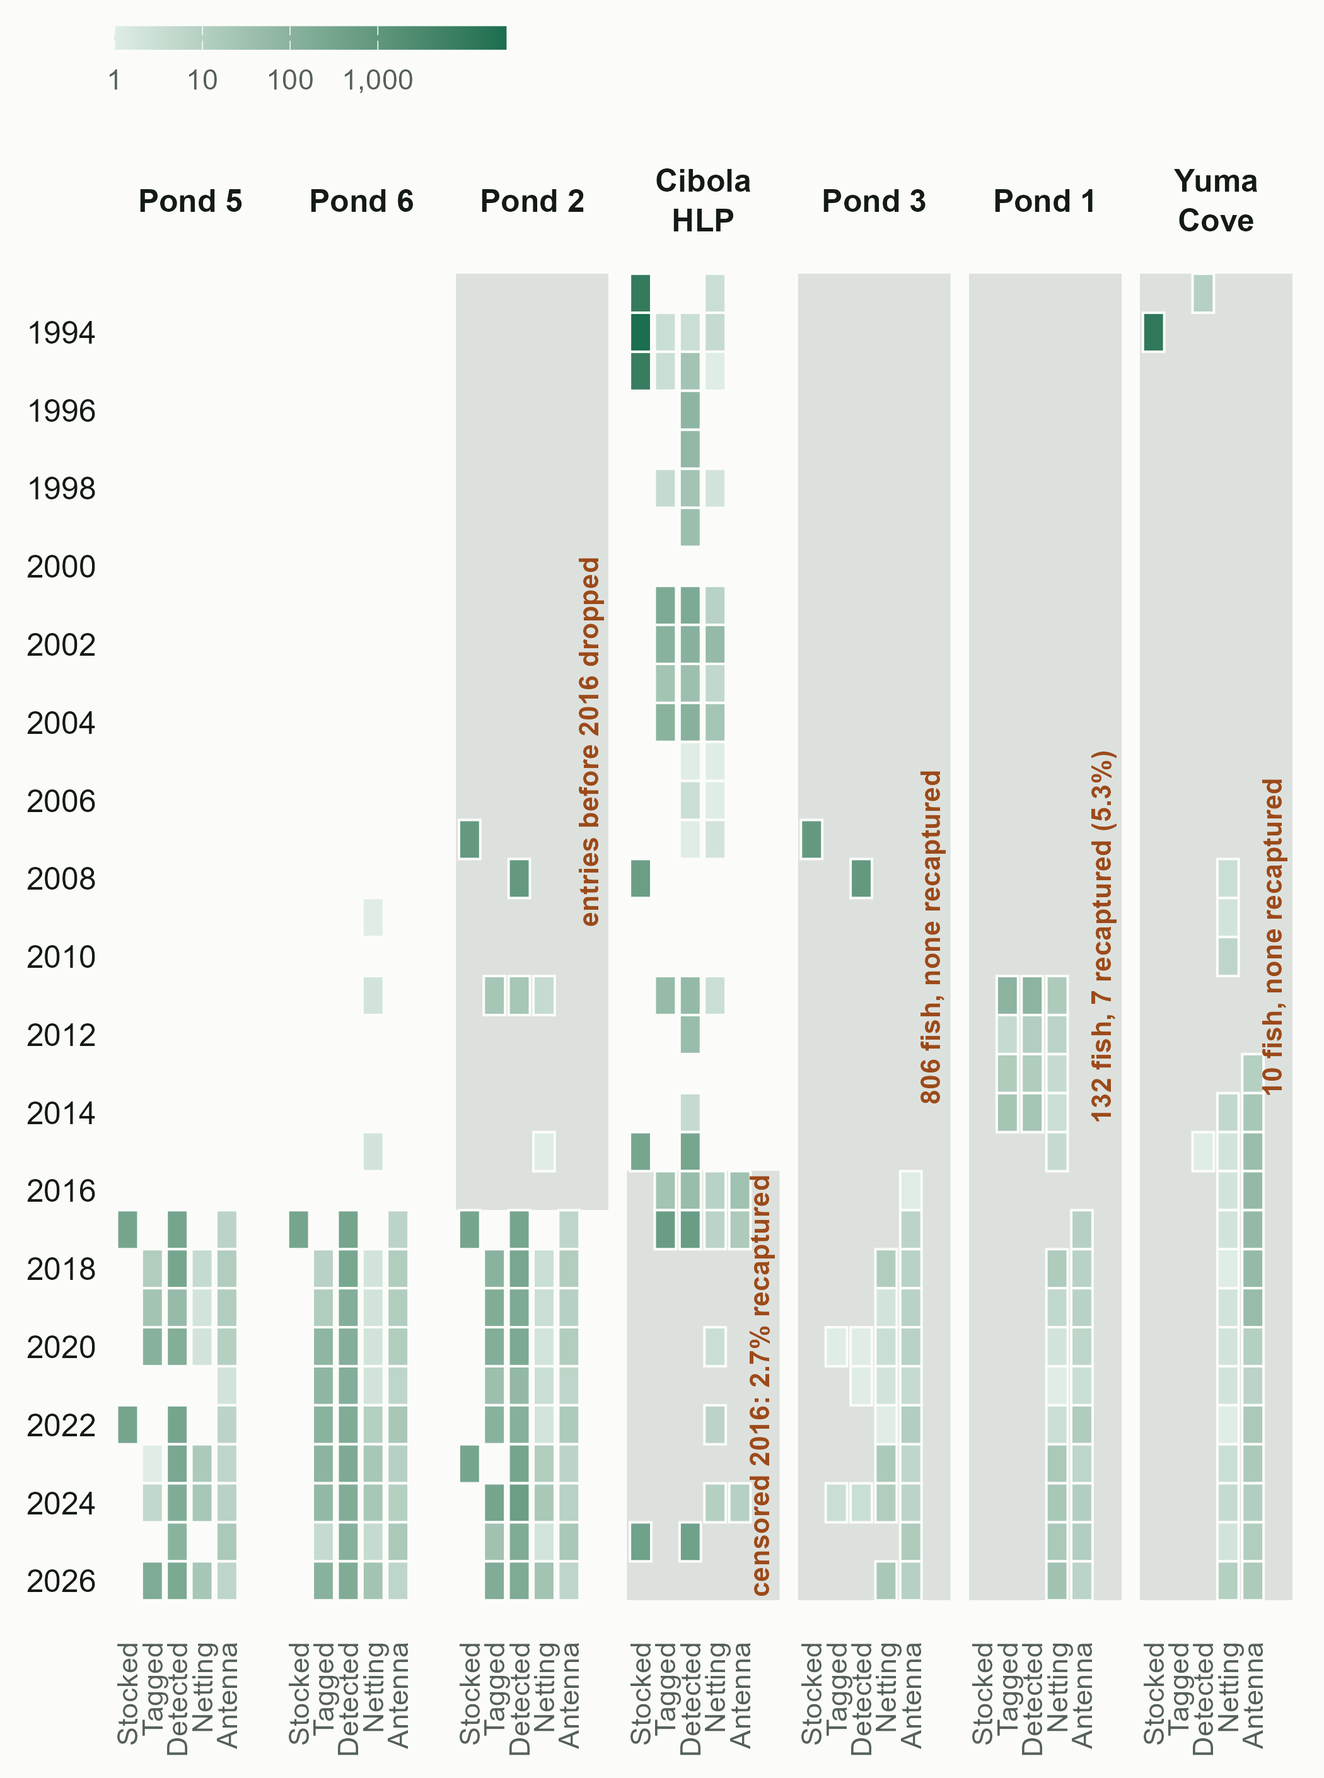
Figure 3. Data-stream coverage by off-channel site and year. Cell shading is the count on a log scale (legend, upper left); grey panels with red annotations mark the periods and ponds set aside during data assembly, and the reason for each.
Three Imperial Ponds sub-ponds (Ponds 2, 5, and 6) and Cibola High Levee Pond carry enough coverage to be modeled. The remaining sites, and certain periods within the retained ones, are set aside on criteria fixed during data assembly, before any estimates were seen:
- Ponds 1 and 3 and the Yuma Cove backwater are dropped: they carry almost no survey effort and recapture never exceeds 5.3%, so neither survival nor detection is identifiable.
- Pond 2 entries before 2016 are dropped: roughly 800 fish stocked in 2007 were never detected again, under a handful of net-nights across the intervening years.
- Cibola High Levee Pond is censored from 2016 onward: of the fish handled there after that point effectively none carried an existing tag, so within-pond closure is violated.
The retained coverage defines the analyzable dataset on which every off-channel estimate rests; the figure is the audit that justifies it, and the same coverage view is what a future site would be measured against.

5. Estimating reproduction (F) from parentage
Reproduction is the parameter that closes the life cycle in the isolated off-channel ponds, and it is the one bonytail vital rate measured directly rather than inferred from a function. F is the per-adult recruitment rate (spawning participation × per-capita reproductive success), and it is estimated from genetic parentage of the larval / young-of-year (YOY) samples genotyped each year against the pond's adult pool.
The adult pool is genotyped as completely as a closed pond allows, together with the captured larvae and YOY, and each offspring is assigned to whichever of its parents are represented in the panel (both where both were genotyped, otherwise one or none). This observes the realized family structure directly, so the model needs neither a females-only device nor a stock–recruit function to identify who reproduced: reproduction is observed rather than reconstructed from per-female fecundity or a stock–recruit curve. Parentage yields three quantities at the individual level, for both sexes:
- Spawning participation is the fraction of adults assigned at least one offspring. In the pond study this was high in most pond-years (89–92% in 2014, 87–99% in 2015) but collapsed in a poor year (Nine Mile 2016: 33% of males, 27% of females), showing that participation itself is environmentally driven (Osborne et al. 2018). This answers who bred, which cannot be observed any other way.
- Variance in reproductive success is the skew in offspring number across adults, driven by environmental factors rather than mating system (Osborne et al. 2018). This term is not cosmetic: it sets how over-dispersed recruitment is, and a naïve Poisson assumption would badly understate year-to-year variability.
- Relative per-adult reproductive output is the distribution of contributions across individuals of both sexes, including the many that contribute nothing.
Because these are ratios and distributions, they are estimated without bias from a representative genetic subsample; the program need not capture every YOY. The absolute magnitude of F (recruits per adult) is not identifiable from parentage alone, however; it is pinned jointly with the trammel-net recruit counts, which supply the total while the genetics apportion it across parents. The quality of the estimate is governed chiefly by the completeness of the adult genotype panel: an offspring whose true parent was not genotyped cannot be assigned, and participation is then biased low. The closed, stocked pond populations are what make a near-complete adult panel feasible, and are why F closes the loop only in the isolated ponds.

6. Covariate structure: linking vital rates to their drivers
The central analytical product of Sub-Task 2 is not a single set of vital rates, but the identification of which environmental and management covariates drive those rates, and with what direction, magnitude, and uncertainty (research questions Q2, Q3, Q6, Q7, and Q15). Covariates enter the model on the linear-predictor scale of each rate:
log F = α + β_{env} · X_{env} + ε
logit φ⁴ = α + β_{env} · X_{env} + ε
logit φ³ = α + β_{rel} · X_{rel} + ε
where α is the rate- and pond-specific baseline intercept, β the covariate slope, X the observed covariates, and ε a year-specific random effect.
The ε term is a temporal (year) random effect: one draw per year from a common Normal distribution whose standard deviation is itself estimated. It absorbs environmental stochasticity that the measured covariates do not capture, so that unexplained year-to-year variation is estimated as process variance rather than being forced onto the covariate slopes or a constant rate. Recruitment F carries its own process error, which keeps year-to-year swings in production distinct from the covariate-driven mean; operational anomalies such as the 2020 and 2022 IPCA die-offs (well pump failure; Marsh et al. 2024) are absorbed here as one-off shocks rather than covariate signal.
Two covariate sets act on different rates, reflecting the two-component design: environmental covariates act on the pond rates (established-adult survival φ⁴ and recruitment F), while release and habitat covariates act on post-stocking survival φ³. Established-adult survival is additionally structured by origin: stocked and wild-hatched fish are estimated separately, with the stocked-versus-wild contrast allowed to differ among ponds rather than pooled, since the two origins need not survive alike and their difference may itself be pond-specific. The first-year survival advantage is correspondingly a release effect carried by stocked fish, not a property of newly-tagged fish in general.
Covariate set | Example Covariates | Acts on
Environmental | Dissolved oxygen, temperature, water level | φ⁴ (adult survival), F (recruitment)
Release / habitat | Reach, size at release, release method, nonnative-predator load, release timing (season), release site | φ³ (post-stocking survival)
Sex | Male / female (known at release; confounded with release size) | Not carried (sex assignment unreliable; see §6)

Sex is not carried as a survival covariate. It is assigned by external examination, which fails for a substantial fraction of bonytail, so a male-versus-female survival contrast is not reliably identifiable, and where it can be examined it is confounded with size at release. The underlying concern is nonetheless real: pond experiments have documented lower survival for stocked males than females (Marsh et al. 2024), and sex-biased mortality would skew the adult sex ratio and, with the variance in reproductive success, lower the effective number of breeders the off-channel refuges are managed to protect. That concern is carried through the variance-in-reproductive-success term and genetic management rather than through a fitted sex effect on survival.
Figure 4 shows this structure. The covariate slopes β are shared across ponds (a single coefficient per covariate, estimated by pooling all the data), while the baseline intercepts are left pond-specific. Sharing the slopes, rather than drawing pond-specific slopes from a hyper-distribution, is the deliberate response to having only a few ponds: ponds might sit at very different baseline survival or productivity yet are assumed to share a common covariate response, such as how strongly low dissolved oxygen depresses survival (Gelman and Hill 2007). This is the more transferable structure for the refuge-site scorecard, because it is the covariate responses, not the pond-specific baselines, that generalize to new candidate sites.
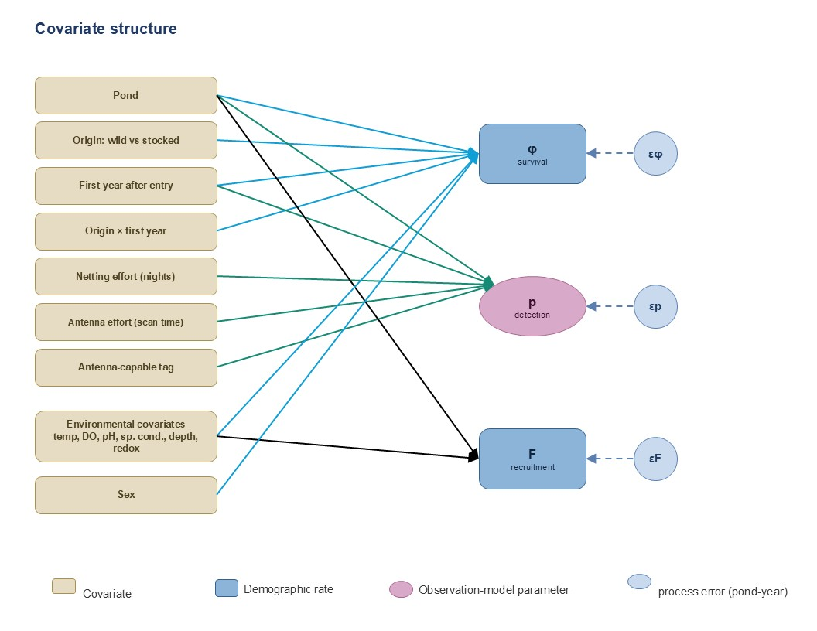
Figure 4. Covariate structure. Tan nodes are observed covariates; dashed teal marks a covariate entering a rate's linear predictor through a slope β shared across ponds (one coefficient per covariate). Grey dashed εF, ε⁴ and ε³ are year (temporal) random effects on the three rates, sharing a common estimated variance σyear; survey effort / coverage enters the detection probability p. Baseline intercepts are left pond-specific.
A note on what these few ponds can and cannot support. The dividing line for a covariate is the scale at which it varies, not the number of fish captured. Individual-level covariates (size at release and release method) vary among fish within a pond, and the environmental covariates (dissolved oxygen, temperature, water level) are measured per pond per year, so both rest on genuine within-pond replication. The individual-level slopes are on firm ground; the environmental slopes are identified from natural year-to-year variation in these variables.
A covariate that instead takes a single value per pond is a different matter. Site identity, or any habitat attribute summarised at the whole-pond scale, has effectively as many observations as there are ponds; pooling individuals to estimate its effect treats non-independent fish as replicates (pseudoreplication) and overstates precision, and with only a handful of ponds the effect is not reliably identifiable by any scheme. Such site-level covariates are reported descriptively unless they can be resolved to the individual or location scale (for example, local bathymetric complexity at each fish's capture site), which returns them to the estimable within-pond set.
Which of these roles a covariate takes is dictated by the field protocol, not chosen in advance. A variable recorded only at fixed stations (dissolved oxygen at a pond logger, or detection effort at an antenna, for instance) describes that station when it feeds detection and samples the pond when it feeds survival: the first case calls for a station-level random effect in the observation model, the second for the reading to enter a survival predictor with measurement error. The covariate structure here is therefore provisional: during data assembly the spatial and temporal resolution of each covariate is confirmed against the monitoring protocol, which fixes its role and whether a station-level random effect is warranted.
The same few-units limit is why the vital rates themselves are fitted per pond rather than pooled across ponds. Pooling rates through a hyper-distribution requires estimating the among-pond SD (τ) from the spread across ponds; the salmon multi-population IPMs this framework draws on (Buhle et al. 2018) do so across roughly 29 Chinook populations, whereas only two core off-channel sites (CHLP, IPCA), with a few more where data support, are available here. With so few groups τ is weakly identified and any pooling is driven by its prior rather than the data, so partial pooling is not adopted.

7. Key assumptions and caveats
- Open water carries no persistent population. The CJS-only treatment assumes post-release fish do not establish; if meaningful open-water persistence were detected, that assumption would need revisiting.
- Open-water survival is near-zero but strictly positive and estimable. The post-release antenna-contact record shows fish alive for weeks to months before contacts decline: that decline is the CJS signal, so survival is identified on the sub-annual timescale. Annual apparent survival is estimated to be near zero (fish do not persist across years); it is not fixed at zero, since exactly-zero survival would make φ and p non-identifiable.
- OCH ponds are effectively predator-free with demographic continuity. This is what permits a state-space process and natural-recruitment estimation; the 2020 and 2022 IPCA die-offs were operational failures (well pump failure; Marsh et al. 2024), carried as one-off process anomalies rather than natural environmental thresholds or model failure. The dieoff at CHLP in the early 2000s (see Mueller 2006) similarly was due to a one-off massacre after someone ruined a multi-year experiment by releasing largemouth bass into pond, which had been free of at least the large nonnative fishes before then.
- Data are QA/QC'd and individual-level. The model depends on clean, de-duplicated PIT-tag histories linked across institutions.

8. Closing synthesis: from simple to complex
The bonytail analysis is best understood not as a single model but as a deliberate progression of increasing structure (Figure 5). It begins with the simplest defensible model, a survival-only CJS for open-water releases, where fish do not establish, and adds capability only where the data justify it: an off-channel CJS that estimates survival and detection in the ponds with pond entered as a fixed effect; covariate slopes (shared across ponds) fitted on that survival to identify its drivers and generalize to new sites (Figure 4); and, at the top, the state-space integration of abundance and recruitment (F) that closes the life cycle, in the isolated ponds where reproduction occurs (Figure 2). Survival and its covariates are pinned down first, so recruitment enters last, on an already-validated backbone, rather than being untangled from survival and covariates all at once.
Each rung buys more inference but demands more data and more assumptions, so the analysis climbs only as far as each pond's data support. In practice the stages coexist: open-water releases, where fish do not establish, stay at the CJS rung; survival and its covariates are estimable across the off-channel sites; and only the isolated ponds where recruitment closes carry the full abundance-and-recruitment model. The model is scaled to the evidence, not the other way around.
(Figure 5 follows on the next page.)

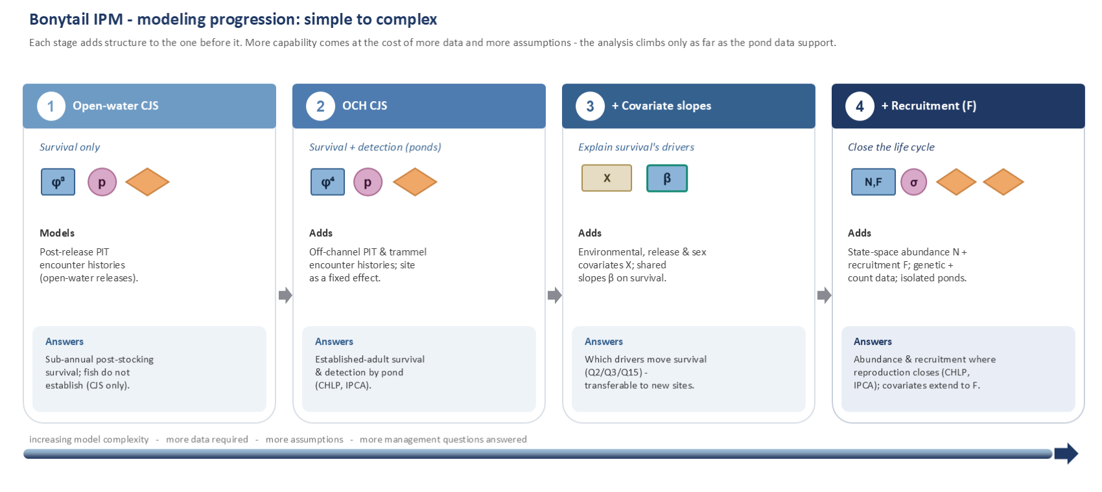
Figure 5. The modeling progression. Each stage adds structure to the one before it; capability rises with the data and assumptions required.

9. Literature Cited
Besbeas, P., S.N. Freeman, B.J.T. Morgan, and E.A. Catchpole. 2002. Integrating mark–recapture–recovery and census data to estimate animal abundance and demographic parameters. Biometrics 58:540–547.
Braun, D.P. 2019. Bonytail (Gila elegans) Basic Conceptual Ecological Model for the Lower Colorado River, 2018 Updates. Lower Colorado River Multi-Species Conservation Program, Bureau of Reclamation, Boulder City, Nevada.
Bravington, M.V., H.J. Skaug, and E.C. Anderson. 2016. Close-kin mark-recapture. Statistical Science 31:259–274.
Buhle, E.R., M.D. Scheuerell, T.D. Cooney, M.J. Ford, R.W. Zabel, and J.T. Thorson. 2018. Using integrated population models to evaluate fishery and environmental impacts on Pacific salmon viability. NOAA Technical Memorandum NMFS-NWFSC-140.
Gelman, A., and J. Hill. 2007. Data Analysis Using Regression and Multilevel/Hierarchical Models. Cambridge University Press, New York.
Kelley, J.R., B.R. Kesner, and P.C. Marsh. 2022. Population Status and Distribution of Razorback Suckers and Bonytail Downstream from Palo Verde Diversion Dam, 2016–2021. Submitted to the Lower Colorado River Multi-Species Conservation Program, Bureau of Reclamation, Boulder City, Nevada, by Marsh & Associates, LLC, Tempe, Arizona.
Kéry, M., and M. Schaub. 2012. Bayesian Population Analysis using WinBUGS: A Hierarchical Perspective. Academic Press, Waltham, Massachusetts.
Marsh, P.C., T.E. Dowling, T.F. Turner, M.J. Osborne, and B.R. Kesner. 2024. Maturation of an off-channel habitat concept to conserve native fishes in the Lower Colorado River. Monographs of the Western North American Naturalist 15:Article 1.
Osborne, M.J., A.V. Sanchez, T.E. Dowling, and T.F. Turner. 2018. Variance in reproductive success is driven by environmental factors, not mating system, in bonytails. Transactions of the American Fisheries Society 147:1100–1114.
Schaub, M., and F. Abadi. 2011. Integrated population models: a novel analysis framework for deeper insights into population dynamics. Journal of Ornithology 152:227–237.
Schaub, M., and M. Kéry. 2022. Integrated Population Models: Theory and Ecological Applications with R and JAGS. Academic Press, London.

